
Contents:
Introduction
Existing System
Proposed System
Software Requirements
Hardware Requirements
Architectural diagram
Data flow diagram
Table Design
Data Dictionary
Relational diagram
Program design
Testing
Conclusion
References
Source code
Screen shot

Introduction:

Amazon is one of the largest e-commerce platforms in the world, and its product reviews are a valuable source of information for potential customers. However, manually reading and analysing millions of reviews is a daunting task. Sentiment analysis can be used to automate this process, by identifying the positive and negative sentiment expressed in a review. This information can then be used to improve the ranking of products in search results, or to identify products that need to be improved.

Existing System:

The existing system for sentiment analysis of Amazon product reviews is manual. Customers submit reviews, and then human analysts read and classify the reviews as positive or negative. This process is time-consuming and labour-intensive, and it is not scalable to large datasets.

Proposed System:

The proposed system for sentiment analysis of Amazon product reviews will use machine learning to automate the process. The system will be trained on a dataset of labelled reviews, and it will then be able to classify new reviews as positive or negative. The system will be able to process large datasets quickly and efficiently, and it will be more accurate than human analysts.

Software Requirements:

=>8GB Ram
=>256 internal memory
=>intel processor

Hardware Requirements:

=>window os
=>Python Gui or Anaconda navigator(Anaconda jupyter)

Architectural Diagram:

The architectural diagram for the proposed system is shown below. The system will consist of the following components:

- A data collection module that will collect reviews from Amazon.
- A data preprocessing module that will clean and prepare the data for analysis.
- A machine learning module that will train a model to classify reviews as positive or negative.
- A web application that will allow users to submit reviews and view the results of the sentiment analysis.

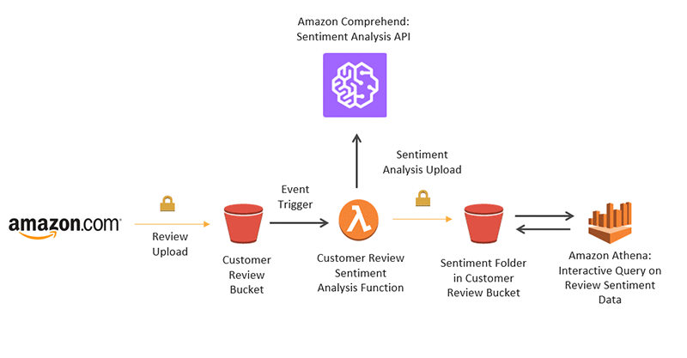
Data flow Diagram:
The data flow diagram for the proposed system is shown below. The data will flow through the system as follows:
- The data collection module will collect reviews from Amazon.
- The data preprocessing module will clean and prepare the data for analysis.
- The machine learning module will train a model to classify reviews as positive or negative.
- The web application will allow users to submit reviews and view the results of the sentiment analysis
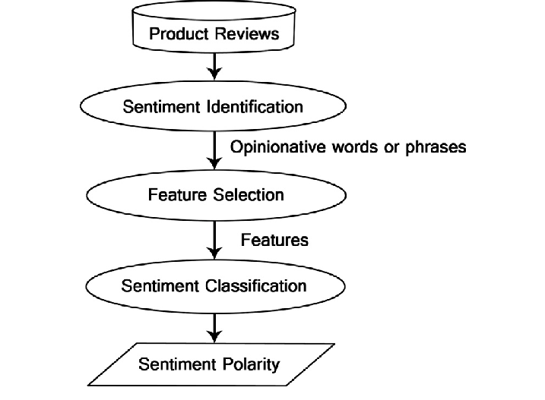
Table Design:
The following table will be used to store the data for the proposed system:
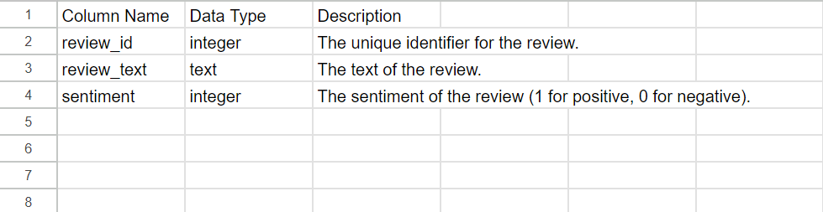
Data Dictionary:
The following data dictionary provides the definitions for the terms used in the proposed system:
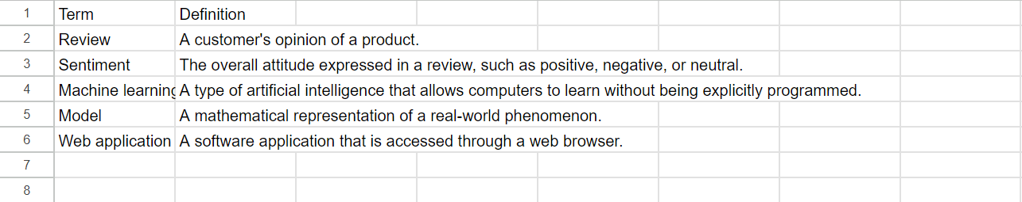
Relational Diagram:
The relational diagram for the proposed system is shown below. The diagram shows the relationships between the tables in the system.
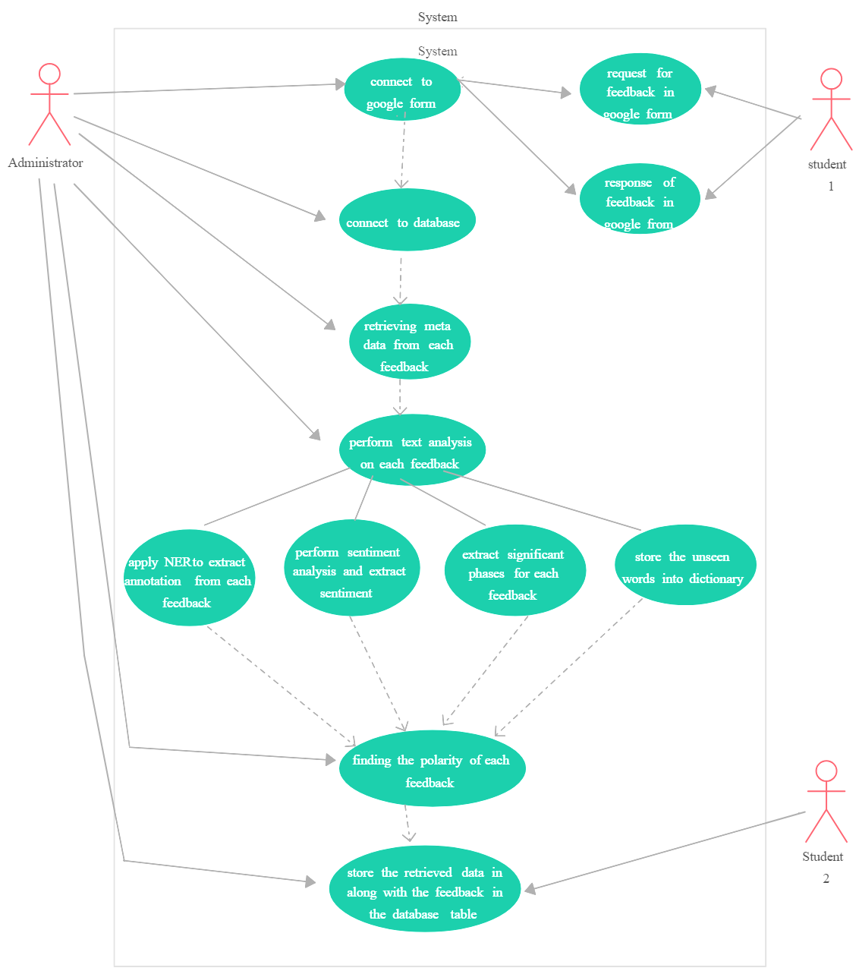
Program Design:
The program design for the proposed system will use the following steps:
- Collect reviews from Amazon.
- Clean and prepare the data for analysis.
- Train a machine learning model to classify reviews as positive or negative.
- Deploy the model to a web application.

Testing:
The proposed system will be tested using the following methods:
- Unit testing: Unit tests will be used to test the individual components of the system.
- Integration testing: Integration tests will be used to test the interactions between the components of the system.
- System testing: System tests will be used to test the entire system.

Conclusion:
The proposed system for sentiment analysis of Amazon product reviews will use machine learning to automate the process. The system will be able to process large datasets quickly and efficiently, and it will be more accurate than human analysts. The system will be a valuable tool for e-commerce companies, as it will help them to improve the ranking of products in search results, and to identify products that need to be improved.
References:
=> From the above we can predict the comment is positive or negative.we can use Machine learning algorithms to predict the sentiment of the comment
=>we are taking the data from Database we have review_body, sentiment_books
=>we are implementing multiple machine learning algorithms based on the requirements naive_bayes ,randomforest,more.. To predict the sentiment of the customer reviews
=>we will evaluated the model of the project to measure the precision and recall for predicted data and find the how accurate the model
=>Once we created the model and evaluated model predict the sentiment of the customer reviews .Then we can deploy the model in the web server
